Etiquette at Muswell Hill Bowling Club

Common sense and Common Courtesy is the guiding spirit behind this guidance:
For bowlers and spectators
- Think about when to move and when to stay still to allow bowlers who are bowling to focus on their shot
- Try to keep non-match related conversations with the players to a minimum (or ideally before or after the game)
- Look after the green – the most important asset in the club
- Remember in competitive matches you are representing Muswell Hill BC
Before the game
- Check out the rules of the game (see this website for a copy of the up to date rules) and the rules for the match you are playing
- White or greys or casual – what is the difference?
- Better not to be wearing bowling shoes when you arrive – change into them before the game
- When at home, welcome visitors and help set up the rinks
During the game
- Try to avoid walking across the green
- Do not drop your bowls on the green
- Do not sit on the bank – it causes unwanted wear on the edge of the green
- Never complain about any green, including our own
‘Possession of the rink’ must always be respected.
- “Possession of the rink shall belong to the team whose bowl is being played. The players in possession of the rink … shall not be interfered with, annoyed, or have their attention distracted in any way by their opponents.”
- Stand well behind the mat or the head, keeping still and quiet while others are delivering their bowls.
- Questions, information or instructions should only be exchanged while you have ‘possession of the rink’ – as soon as your bowl comes to rest, ‘possession of the rink’ is transferred to the opposing player or team.
Positions
- When at the head, bear in mind that some bowlers like a clear view of the rink markers. Stand behind the head, inside the rink markers, but not obscuring the central rink number.
- When at the head in sunny conditions, or as the sun sets, avoid standing where your shadow is cast over the jack, making it difficult to see from the mat.
- Similarly, standing directly behind a white jack in white shoes can make the jack difficult to see.
- Players at the mat-end of the rink who are not delivering a bowl should stand at least one metre behind the mat.
Responsibilities
- Follow your skipper’s directions (even when you do not agree!)
- Number threes (or twos in a triple) give directions for the skipper
Results of an end
- The result of each end (including measuring where required) is determined between the threes (or twos in triples). Other players should not be involved.
- Do not disturb the head until the result of the end has been agreed.
General
- Keep all comments positive and constructive
- Provide help by indicating how far a bowl is from the jack.
- ‘Call’ or shout at your own bowls by all means – but not your opponents’!
- Commend good shots.
After the game
- Congratulations all round and offering to buy your opposite number a drink is the usual form followed by the members of Muswell Hill
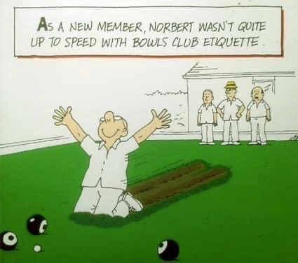
With thanks to the website of North London Bowling Club for ideas as to content
June 2021

